**Working of Spring Container**

**Primary Function of Spring Container**

**Spring Configuration can be done by:**

**1. Java Annotations**

**2. Java Source Code**

* **Inversion of Control (IoC)**

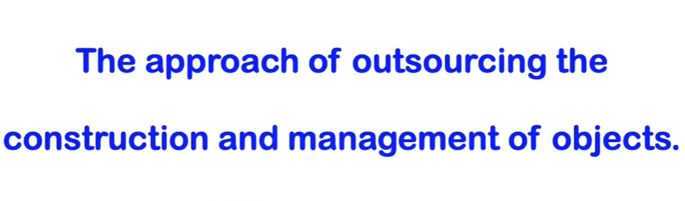

* **Dependency Injection**

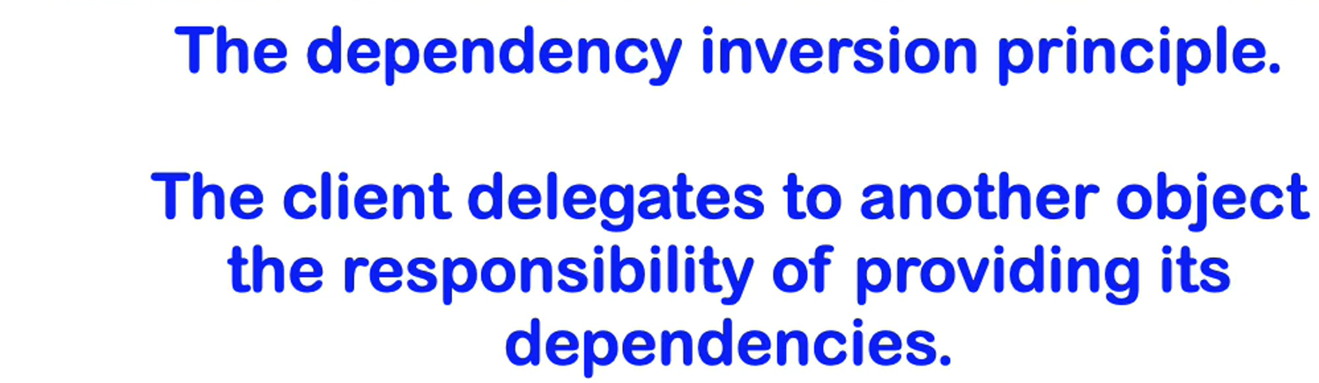

**Two types of Dependency Injection:**

1. **Constructor Injection**
2. **Setter Injection**

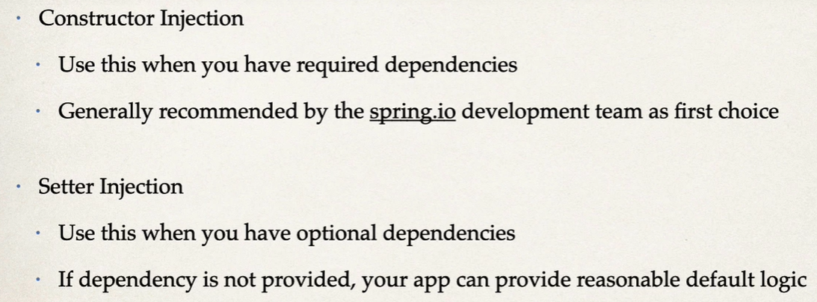

**Spring AutoWiring**

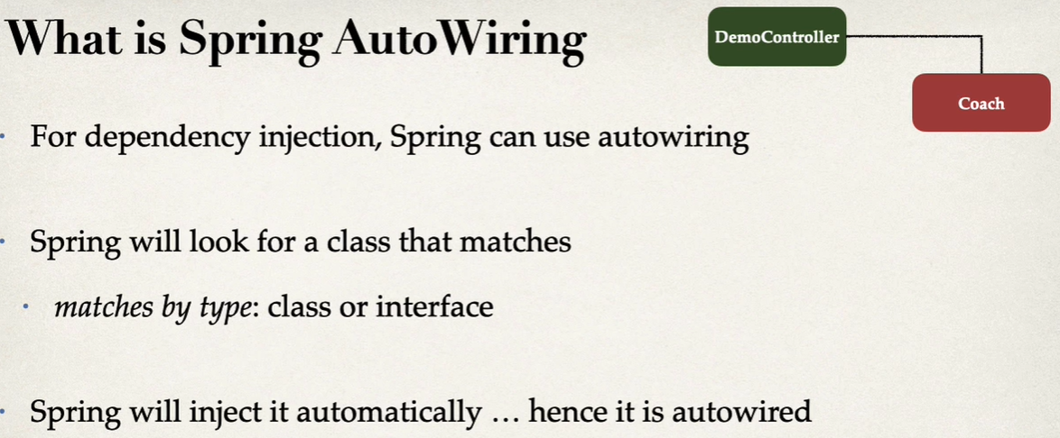

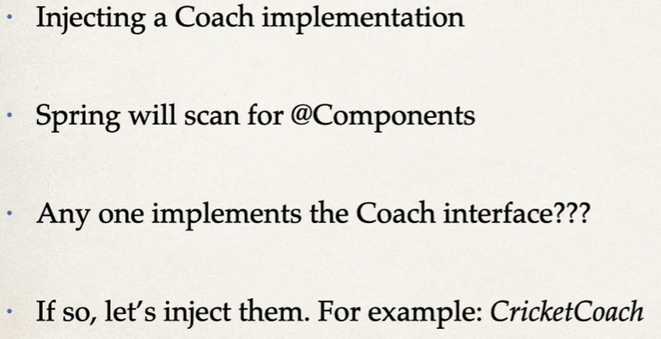

**Setter Injection –**

**When dependencies are injected by calling setter methods on your class**